**[Air rifle Stock Building by howie1a Part 1](http://www.gatewaytoairguns.org/GTA/index.php/topic,24891.msg225681.html" \l "msg225681)**

January 23, 2012, 10:38:23 AM

I thought I would put some info on stock building since some of you have asked how to go about it. I know this is in the china gate but I mostly work with China Rifles. If Gene wants when this is completed  he can put it into the Library  , I will have to make it in more than one post since I don't think I can put enough pictures in one post. So here we go. The first thing is to get 2 pieces of 3/4 " wood about a 1"x8"x8 '  will do when glued together using marine epoxy glue you get a 2"x8"x4 ' piece most of the time I can get 2 stocks out of this  mtl. I make my stocks from 2 pieces to prevent warping , also when gluing together I put a 4 ft I beam I have and clamp this on the mtl. first to straighten out the stock mtl. them I put the rest of my clamp's on about 20 . After it has cured  for 24 hrs. I can remove the clamps and dress the edges of the stock mtl. Now I can lay out a over size blank on the mtl. then cut to the over size stock blank out The next thing is to lay a stock from the rifle you want to copy ( note you are only going to copy the inletting. ) You must leave the outside on a square shape id you make any changer to the with or the top of the stock you will have a lot of problems. Now I locate the end of the chamber this is where all measurements are taken from, and use my 2 hp router maunted up side down on my saw table , this is lets me to use the fence on my saw to get a straight cut. In the pics. you can see some of the tools I use and how I lay out a stock. I am in the process of making a pair of Walnut stocks for a Ruger AirHawk rifle. And you can follow along.

Howie

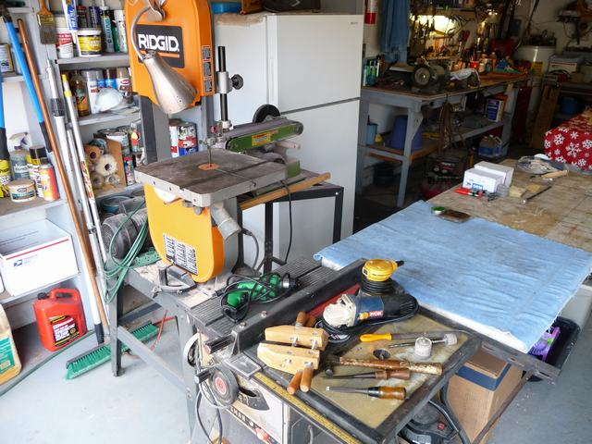

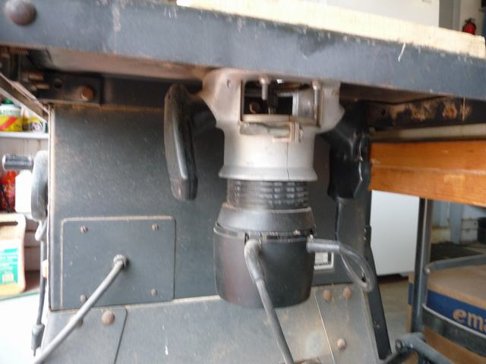

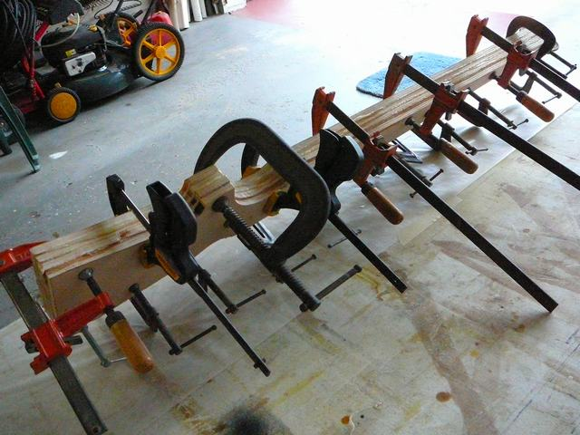

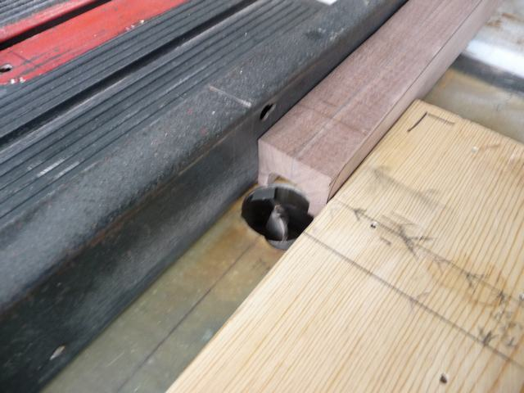

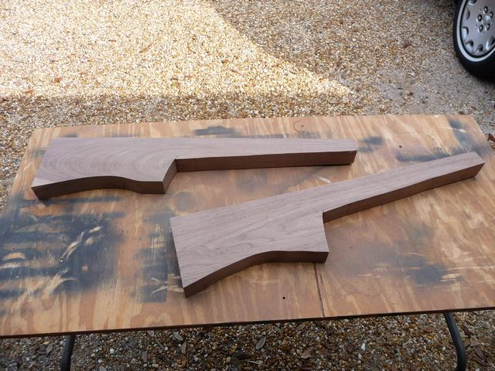

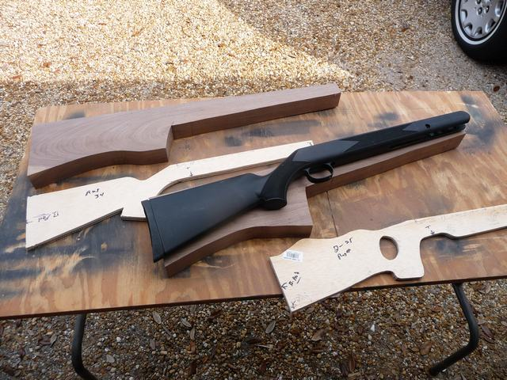

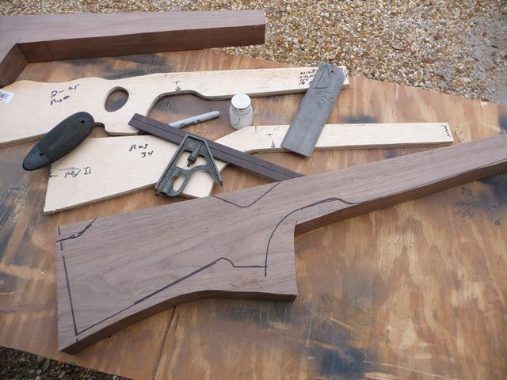

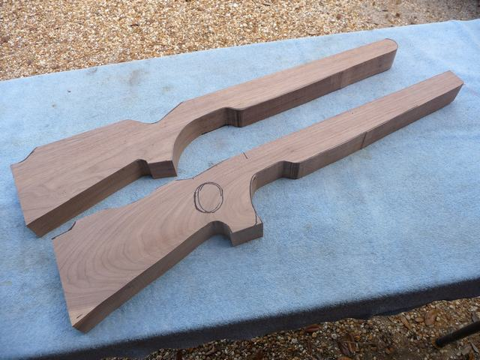

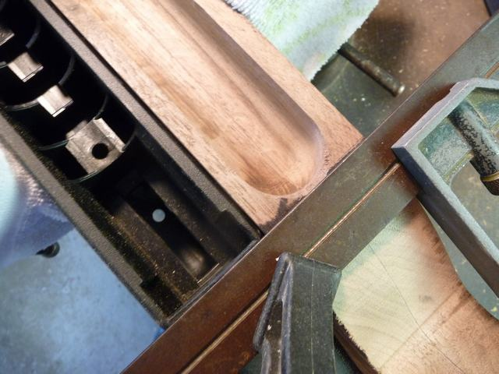

[**Air rifle Stock Building by howie1a Part 2**](http://www.gatewaytoairguns.org/GTA/index.php/topic,24900.msg225775.html#msg225775)

January 23, 2012, 01:02:01 PM

OK we have another 12 pics. mostly showing the tools I use for doing the cutting out of the part of the stock where the action goes , as you can see I still use the same starting location , and the stock is still in the square shape that is the sides and the top we need these for working off. The last picture show's me marking out where the   groove is  for the cocking linkage as well as the cut out I will be doing with a table saw as we go into the next steps. we will shape them after the action has been put into the stock and is able to be fired. I think the pictures are much better than I can describe.

Howie



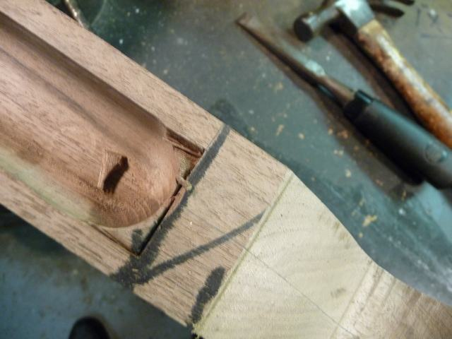

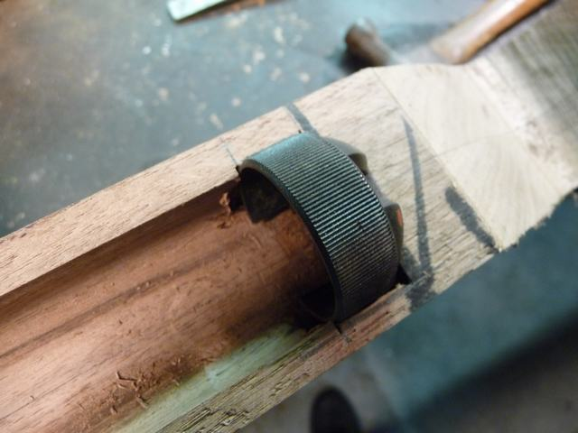

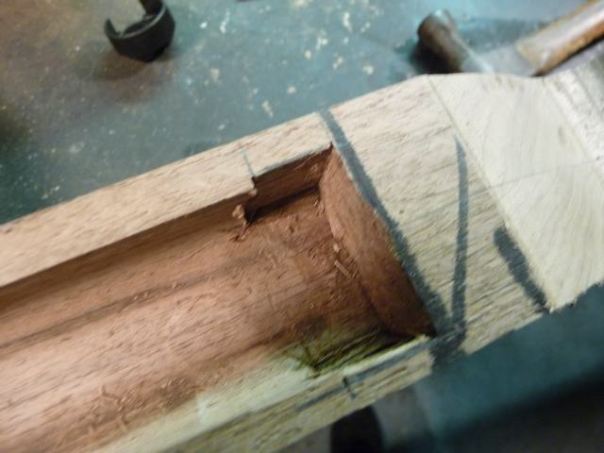

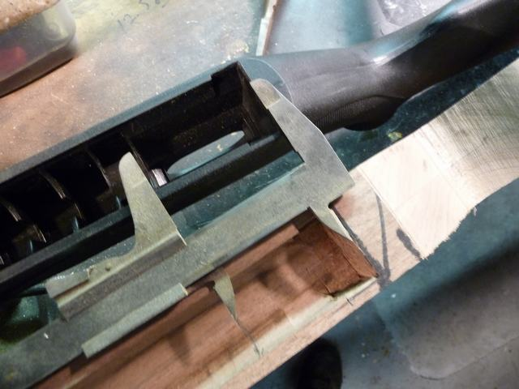

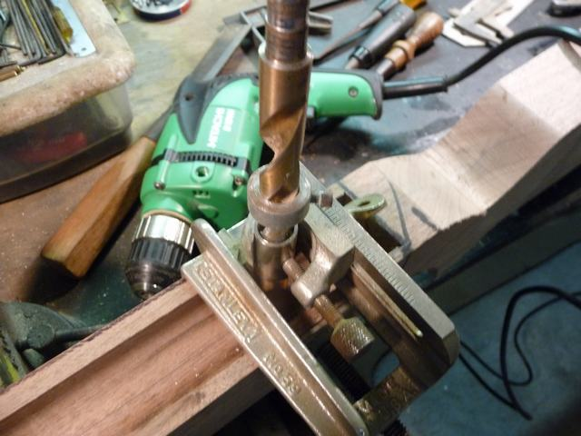

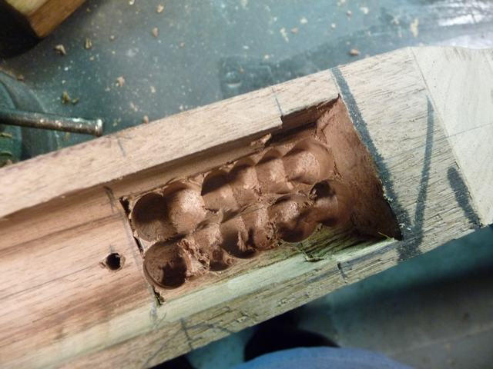

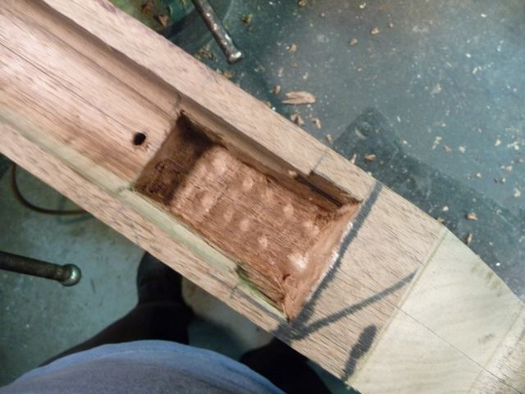

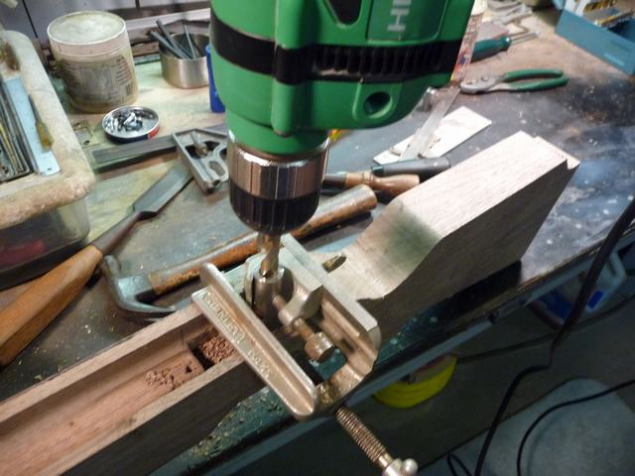

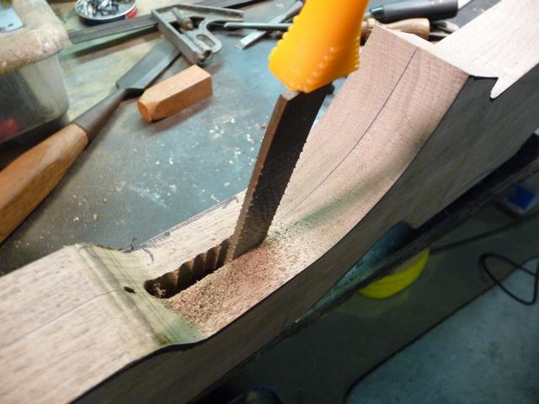

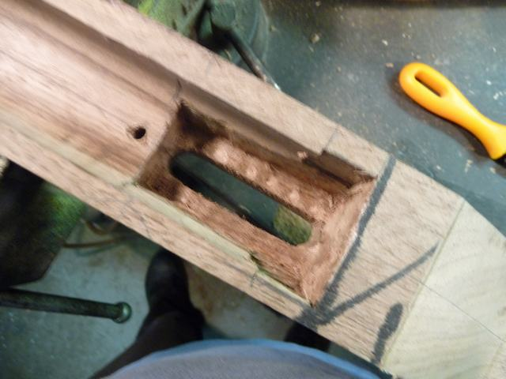

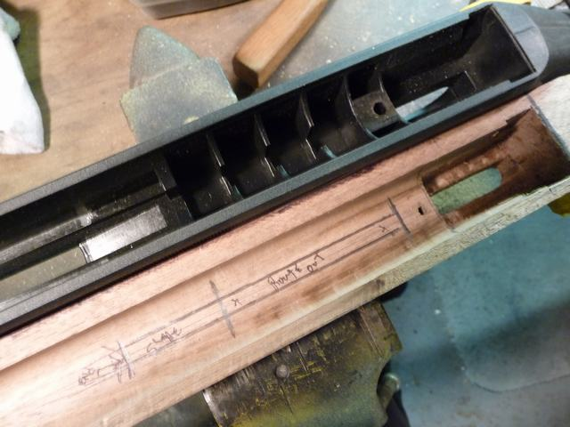

[**Air rifle Stock Building by howie1a Part 3**](http://www.gatewaytoairguns.org/GTA/index.php/topic,24936.msg226266.html#msg226266)

January 24, 2012 at 10:22:21 AM

Hi here are some more pics of the stock we are making , we are making the slot for the cocking linkage and the inside clearances for the cocking linkage , as you know I use the old stock to transfer the places that make it possible to match the old stock. You will see that some of the cutouts have to be made with a table saw and some of the cutting is done with a router that I have made some changes to so it will do the job. In the pic,s 160 to 170 I am locating the holes for the forward screws in the stock I use some masking tape to mark where the top of the stock is and the center of the screws then transfer the location to the outside of the stock. The end pics show that the gun has been put into the stock and shot so we know all the cuts work and in this case no reliving of the stock was needed  also I have put the yellow heart trim on and the butt pad after checking that the LOP is right I like about 13 3/4  " I will put more pictures in the post #4 since I can't get them all on this post.

Howie

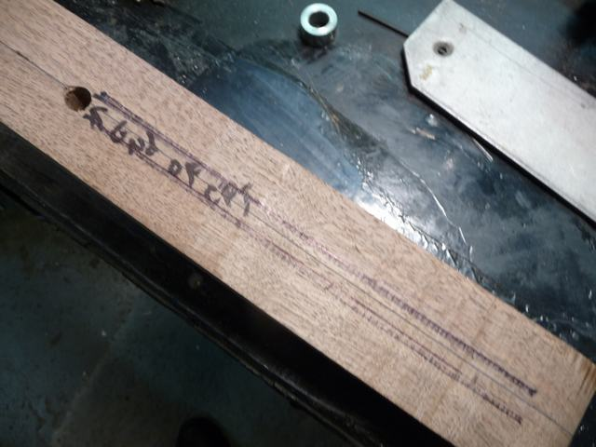

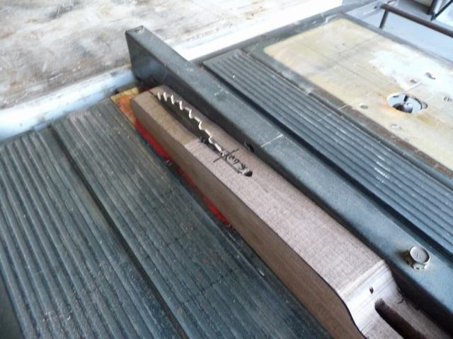

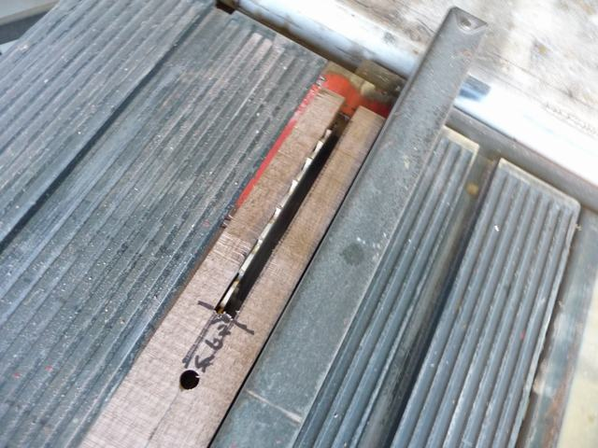

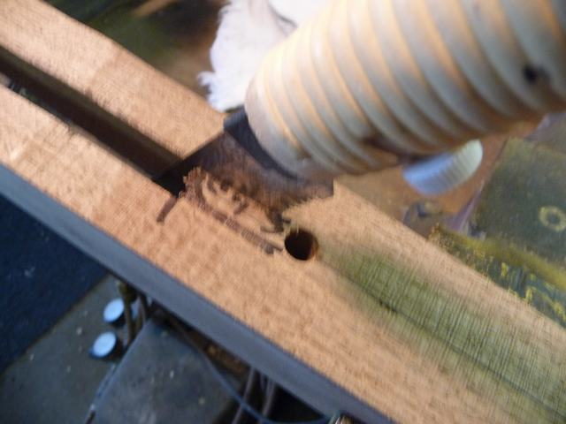

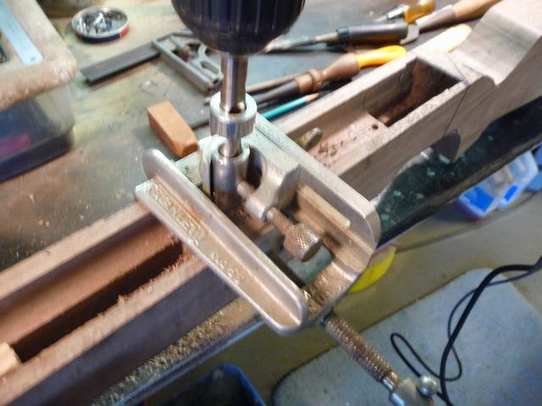

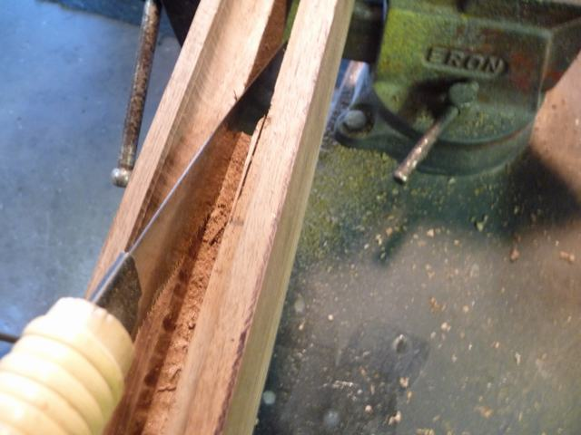

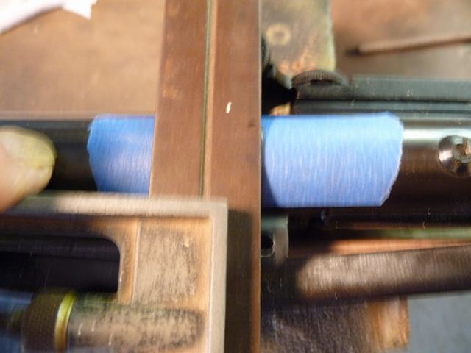

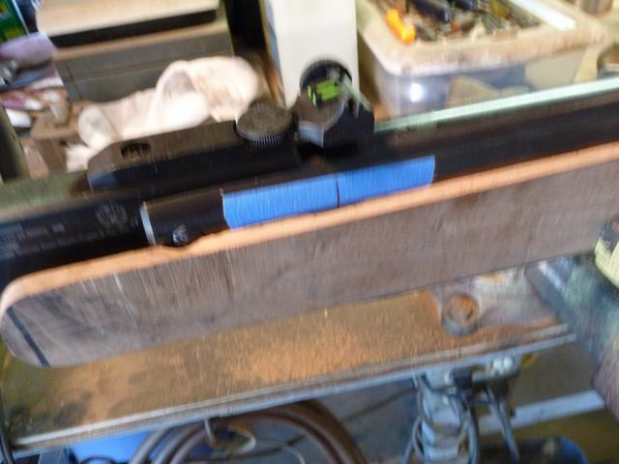

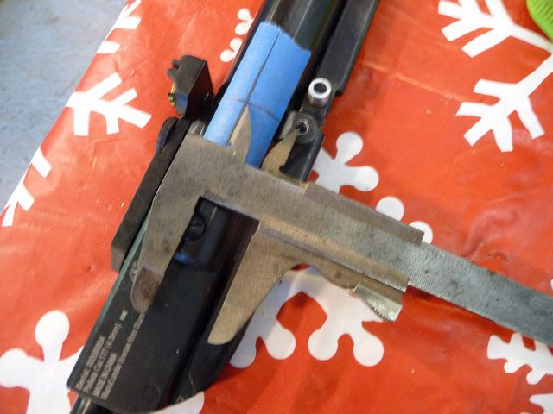

http://www.gatewaytoairguns.org/GTA/Themes/CustomGTA2012/images/post/clip.gif

[**Air rifle Stock Building by howie1a Part 4**](http://www.gatewaytoairguns.org/GTA/index.php/topic,24937.msg226267.html#msg226267)

January 24, 2012 at 10:26:47 AM

The rest of the pictures from part 3 . the next step will be carving the outside , now we need to let the epoxy glue set up about 24 hrs.

Howie  
  Note: I have ordered some trigger guards from Crosman for the Remington Summit since this rifle has a plastic stock the trigger guard is molded on the stock and we will need a nice metal trigger guard to use for the wood stock .

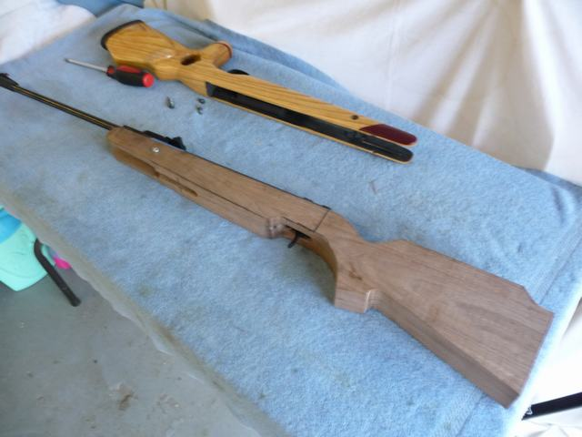

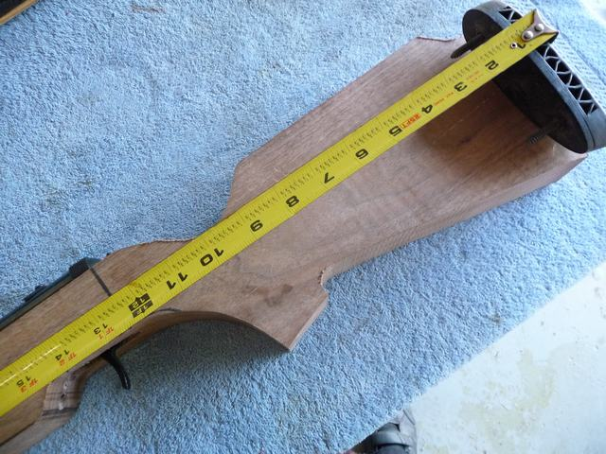

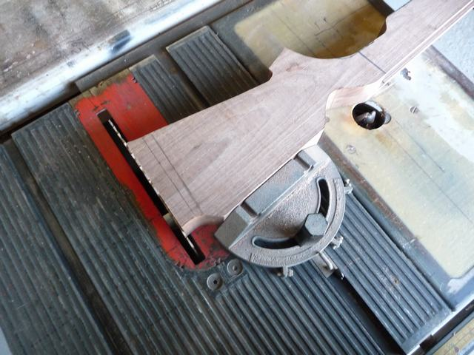

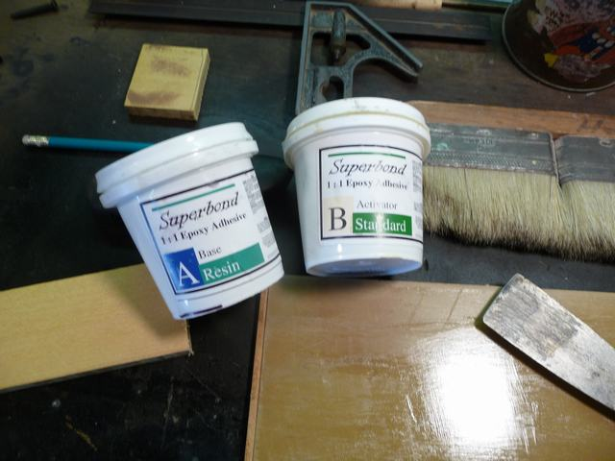

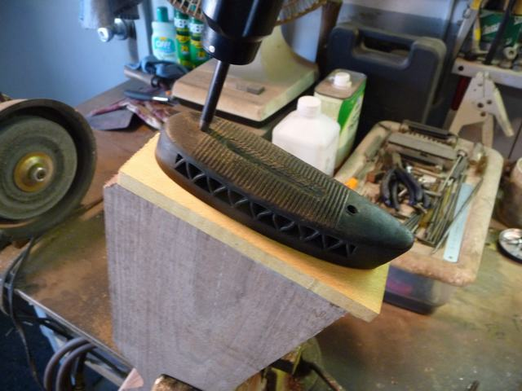

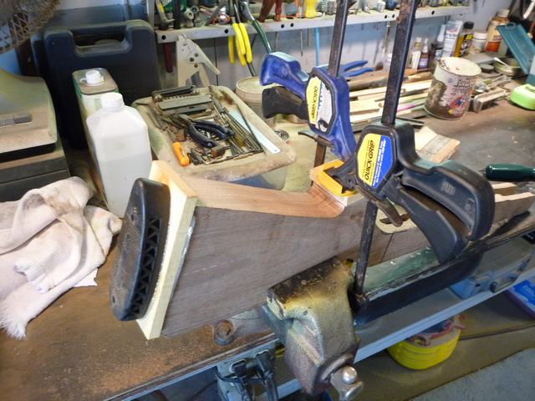

##### [Air rifle Stock Building by howie1a Part 5](http://www.gatewaytoairguns.org/GTA/index.php/topic,25004.msg226829.html#msg226829)

January 25, 2012 at 10:25:02 AM

Hi here are some pictures of the carving of the outside of the stock

